**Name and UNI ： Tianyi Lu tl3126**

Summary of my analysis

[a] Copy and paste (as text or image) your output table below.

Year No. of Tdays Volatility No. of 75bpGaps

2021 238 81.37 7

2020 253 216.89 68

2019 252 78.57 15

2018 251 107.41 21

2017 251 42.12 1

[b] Copy and paste your scatter plot (as image) below.

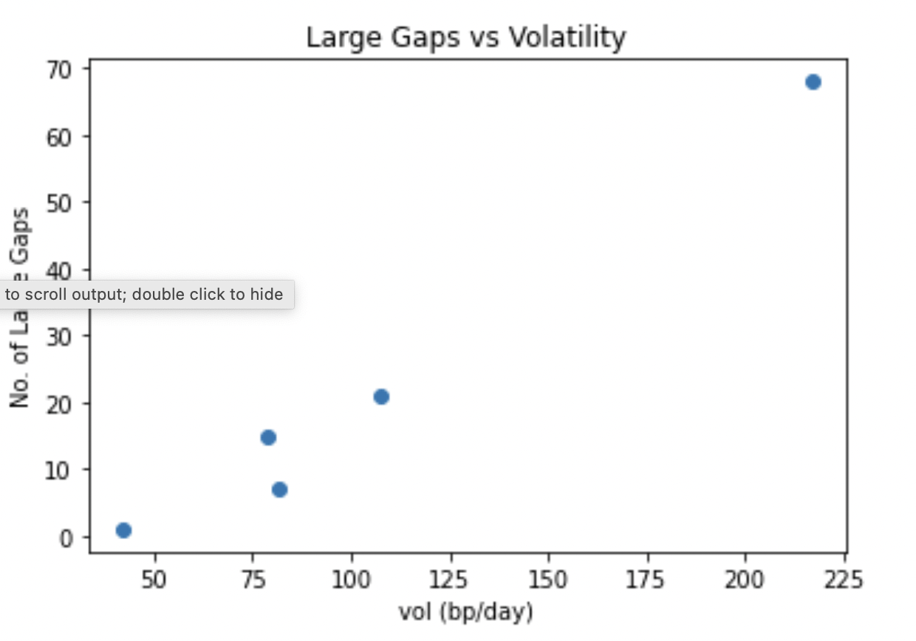

[c] Copy and paste (as text or image) your output table below.

Year No. of Tdays No. of 75byGaps Fitted No. of 75bpGaps

2021 238 7 7.12

2020 253 68 70.59

2019 252 15 11.42

2018 251 21 15.98

2017 251 1 6.88

[d1] Report your prediction for the number of 75bpGaps in 2022 below. Just a number will do.

19.87586

[d2] Report the pseudo-R2 of your fitted model below. Just a number will do.

0.97198

[d3] Report the estimated prediction MRSE below. Just a number will do.

14.09565